KIC Autobahn Safary Berlin Application Form

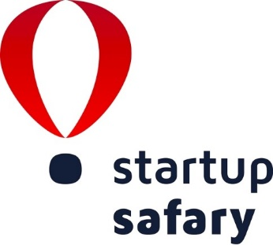

Guidelines

Please answer the following questions to the best of your ability in English. If the question does not apply to your company, please leave it blank. As soon as you finish filling in the application, please convert the document to PDF, print it out, sign and submit it with the supporting documents.

Please attach the following support documents to this application form:

- Company Presentation (in PDF)

Please submit:

- the signed application form with all supporting documents

Ongoing, by email to autobahn@kiceurope.eu

If you have any questions concerning the completion of this document or preparation of your application, please contact us at +32(0)2 880 3904 or by email at autobahn@kiceurope.eu

1_General Information

Company Name

In one sentence, what does your company do?

Industry

Business Established On:
(Day/Month/Year)

Business Form
(ltd, etc.)

Company Size  (Please mark the correct answer) | □ up to 10 employees □ 11-50 employees  □ 51-249 employees □ over 250 employees

Annual Revenue  (Please mark the correct answer) | □ up to 250.000 EUR □ 250.000 – 500.000 EUR  □ 750.000 – 1.250.000 EUR □ over 1.250.000 EUR

How is your company financed? (Please mark all that apply) | □ Founders □ Public Money  □ Investors □ Others ____________________

2_Contact Details

Contact Person
(Name, Function)

Company Address
(Street, City, Postal Code)

Phone

Fax

Email

Website
3_Company Profile

What does your company do? [max ½ A4]
(Brief description of your business activity)

…

What is special about your company? [max ½ A4]
(Key words that describe the uniqueness, competitive advantage and innovativeness of your company)

…

4_Technology and IP

What is the development stage of your technology? [max ½ A4]
(Brief description of the stage of your technology: idea, prototype, product, etc.)

…

How is your technology protected? [max ½ A4]
(Brief description of the intellectual property rights of your technology)

…

What is the competitive advantage of your technology? [max ½ A4]
(Brief description of your unique selling point USP)

…

5_Domestic and International Market

Who are your clients? [max ½ A4]
(Brief description of the main clients)

…

Who are your main competitors? [max ½ A4]
(Brief description of main competitors)

…

What is your position on the home market? [max ½ A4]
(Brief description of your position and activity on the home market)

…

Is your company operating internationally? [max ½ A4]
(Brief description of your current international activity)

…

6_Go-Global Project

What are the short-term objectives of your go-global strategy? [max ½ A4]
(Brief description of your project for the next 3-6 months; e.g. planned activities, targeted markets, etc.)

…

What are the long-term objectives of your go-global strategy? [max ½ A4]
(Brief description of your strategy for the next 1-3 years; e.g. planned activities, targeted markets, etc.)

…

7_Motivation and Needs

Why do you want to participate in the “KIC Autobahn Safary Berlin” program? [max ½ A4]
(Brief description of your motivation)

…

What do you expect from the participation in the “KIC Autobahn Safary Berlin” program? [max ½ A4]
(Brief description of your needs regarding technology, financial, networking and business development support)

…

8_Incubator or Accelerator

Which Incubator or Accelerator do you belong to?
(e.g. CCEI Ulsan)

Confirmation

I certify that the information contained in this application form and the supporting documentation is true and complete. I understand that this application is the first step in the review process for participation in KIC-Europe “KIC Autobahn Safary Berlin”, and that I may be required to attend a meeting (online/offline) with the representatives of KIC-Europe to present the above information for consideration by the Committee and to answer any questions Committee members may have about my company applying to the “KIC Autobahn Safary Berlin”.

Place and Date Name of the Company`s Representative Signature

